Cameron Dearien Mark _____________________/50

## Menu Management __/3

My feature is managing the menus in the game. To achieve this, I will be taking inputs from the user and turning them into meaningful values that the rest of the game can use. I will also be managing the storing and updating of the high scores. In order to get the user input and make something meaningful out of it I will be taking the user input from the player in the form of button inputs on a menu and turning those into numerical values for the rest of the game to use. To manage the high scores I will be taking the score from the score keeper and comparing that value against the current high scores (if there are any) and updating that list if necessary.

## Use case diagram with scenario __14

### Use Case Diagrams

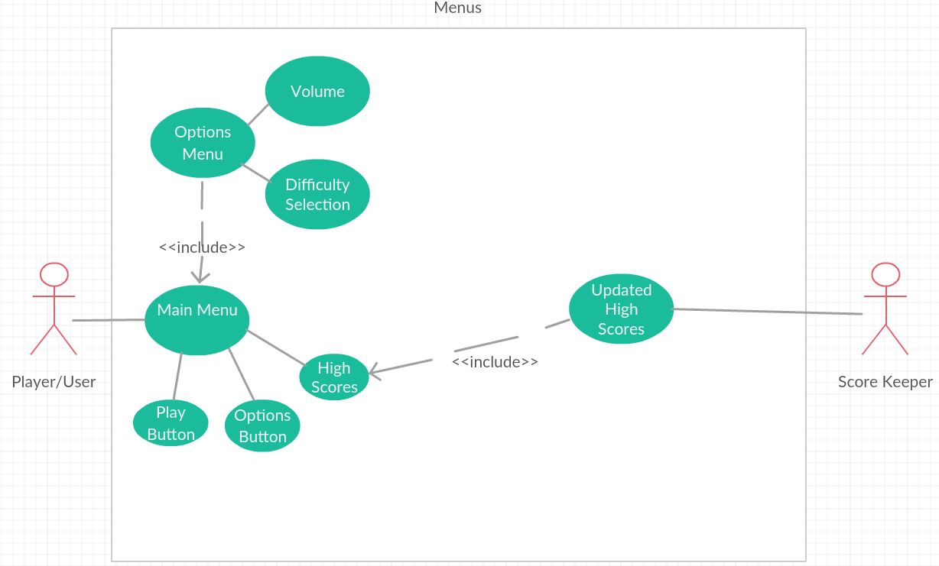

### Scenarios

**[You will need a scenario for each use case]**

**Name:** Main Menu

**Summary:** The user’s interactions with the menu are stored so that the rest of the game can get meaningful values from it

**Actors:** Player/User

**Preconditions:** The user has put on the Vive

**Basic sequence:**

Display the menu

Get user input

For the different buttons do different things

Play button

Play the game with either edited settings or default settings

Options button

Display the options menu

High Scores

Display the high scores

**Post conditions:** Options are saved

**Priority: 3**

**Name:** Options Menu

**Summary:** Allows the player/user to edit the options for the game before starting the game

**Actors:**

**Preconditions:** Button was pushed in main menu

**Basic sequence:**

Display the menu

Get user input

Edit variables for volume and difficulty

**Priority: 3**

**ID:**

## Data Flow diagram(s) from Level 0 to process description for your feature _______14

### Data Flow Diagrams

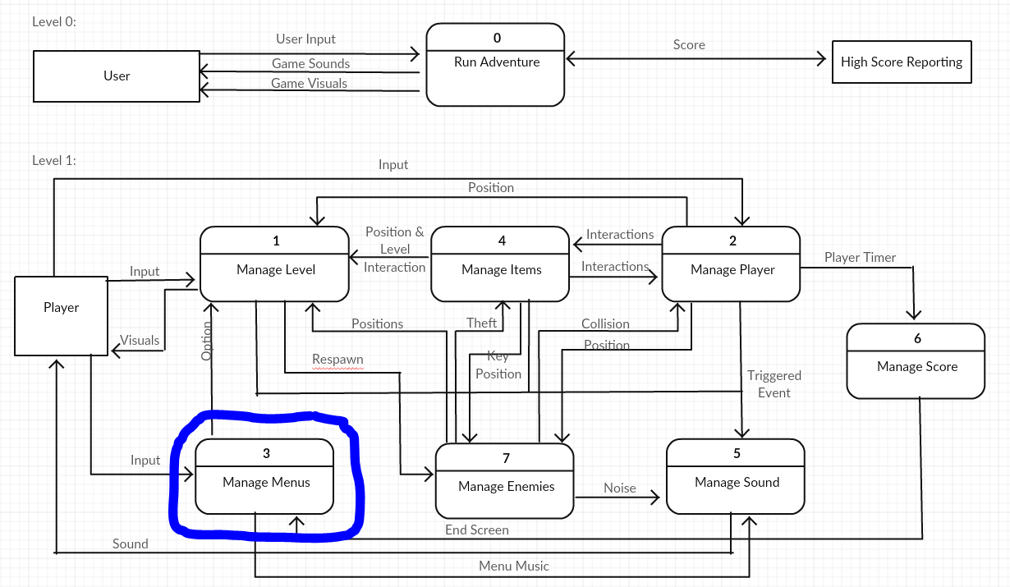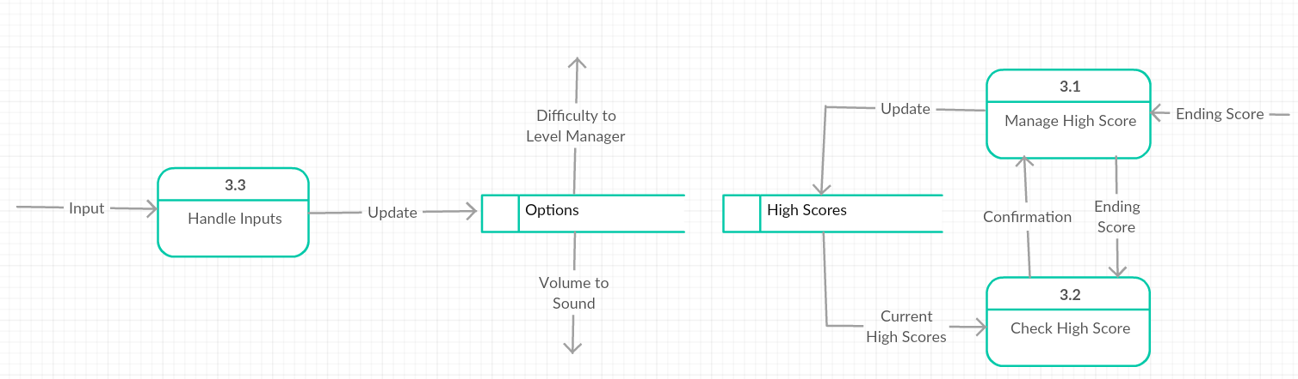

### Process Descriptions

Process Input:

Get the users input from the vive or from the scorekeeper

IF player interacts with buttons

Update corresponding variables

IF scorekeeper sends a new score

IF score > some/all of the high scores

Update high Scores table

## Acceptance Tests ________9

**Example for Manage High Score**

Send a stream of values at the function with X number of known high values, where X is the number of stored high scores. After the test is over, check the file where the high scores are stored and make sure the values match the known high values.

The high score file will have the following characteristics:

* Max number: 30:00
* Min number: 1:00
* Where the lower of the times is better

## Timeline _________/10

### Work items

|  |  |  |
| --- | --- | --- |
| Task | Duration (PHrs) | Predecessor Task(s) |
| 1. Define Settings | 1 | - |
| 2. Menu Layout | 1 | 1 |
| 3. Create Main Menu | 5 | 1,2 |
| 4. Create Scene Switcher | 1 | 3 |
| 5. Create Buttons | 6 | 3 |
| 6. Create Options Menu | 1 | 3 |
| 7. Testing | 6 | 3,6 |
| 8. Installation | 8 | 7 |

### Pert diagram

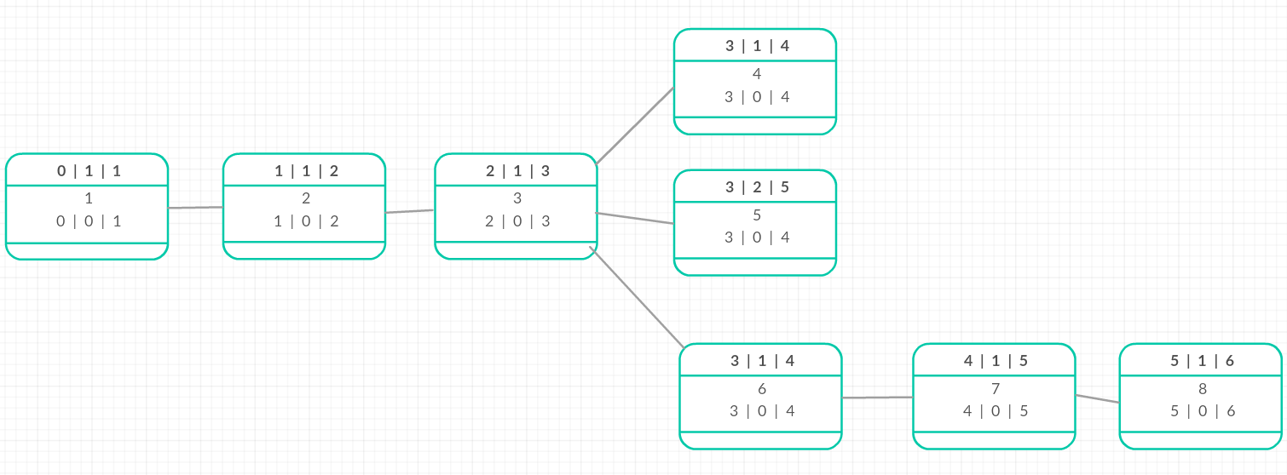

### Gantt timeline

